Below are resources to help you or your employees find affordable housing in the Aspen/Snowmass area. Burlingame and Marolt Ranch are primarily geared toward seasonal employees (Burlingame and Marolt are Winter only). These three properties are especially familiar with the challenges of international workers who are trying to coordinate housing in advance. None of the properties listed below (except the Aspen Skiing Company Employee Housing properties listed at the end) are affiliated with Aspen Skiing Company, but many Aspen Skiing Company employees live at these properties.

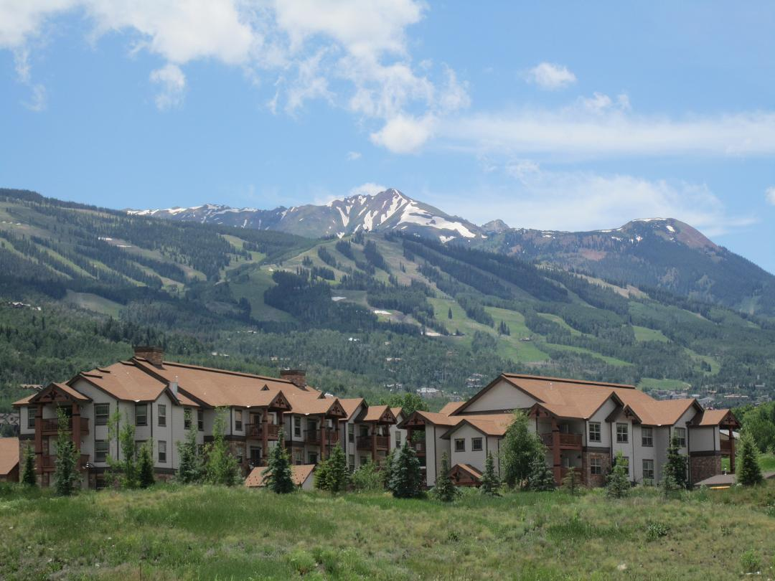

Aspen Skiing Company Employee Housing
26 Commons Circle
Snowmass Village CO 81615
970-922-9001 (Club Commons Housing Office) or 970-927-0202 (Campground/down-valley properties)
housingoffice@aspensnowmass.com
www.aspensnowmass.com/housing
In the winter, this is Housing for Aspen Skiing Company Employees ONLY. Department managers assign employees apartments in the late summer (Aug-Sept) so contact the department manager early. There are sometimes last minute openings once the ski season begins, so it’s worth visiting the website and getting on the waitlist by clicking the “apply now” tab. Summer apartments are open to all, including “non-Ski Co employees,” if available.

Aspen Pitkin County Housing Authority (APCHA)
210 E. Hyman Av, Suite 202 Aspen, CO 81611
(970) 920-5050
www.apcha.org
This office is across from the Limelight’s garage. This is a good option for housing requirements longer than one season. Employment verification is required. This housing office has a great bulletin board for posting roommates needed, seasonal rentals, and longer leases. Please talk to their office staff also to find what other options might be available in the rental properties that they manage. Hunter Creek Apartments, Marolt, Truscott apartments and many more in their inventory.

Town of Snowmass Village Employee Housing (TOSV)
555 Deerfield Drive
Snowmass Village, CO 81615
970-923-2360
teverest@tosv.com
http://www.tosv.com/
Tenants must be year-round employees in the town of Snowmass Village and there is a minimum 1 year lease contract. Office located at Mountain View apartments 555 Deerfield Drive.

Willits Seven
979 East Valley Road
Basalt, CO. 81621
jharrison@romero-group.com
www.willitsseven.com
Willits Seven is a new construction affordable housing complex located in Basalt, CO. Perfectly situated for those working in nearby Aspen, Carbondale and Glenwood Springs, Willits Seven offers the quality and amenities of new construction in an unbeatable location. Comprised of 50 one, two and three bedroom apartments, Willits Seven is located on the corner of East Valley Road and Market Street in Willits Town Center. Close to Whole Foods, R.F.T.A. bus stops, restaurants, the Element Hotel, medical facilities, retail shops, parks and recreation areas, our apartment community puts you within easy reach of everything you need for work, shopping, recreation and more. Willits Seven is an affordable housing property. Selection of rental tenants will be in accordance with Town of Basalt Community Housing Guidelines. All vacancies are listed online. If you have questions, would like to view an available apartment or are interested in applying for a vacancy, please contact.

Roaring Fork Apartments
111 Emma Road
Basalt, CO. 81621
970-927-0507
RoaringFork@RealAmericaLLC.com
http://realamericallc.com/apartments/roaring-fork-apartments/
Brand new!

One 10 Harris
www.one10harris.com
970-279-2110
1/2/3 bedroom apartments
Pet Friendly and 12 month leases
Located in the Willets town center. BRAND NEW!

Burlingame (winter only!)
050 Harmony Place (across from Buttermilk Mountain)
Aspen CO 81611
970-920-0171
burlingamehousing@comcast.net
There are 82 units at Burlingame. The units have 2 bedrooms (1 person per room) consisting of a full bath, 2-burner stove, microwave, and full-size refrigerator. Call for availability and terms.
Marolt Ranch Housing (winter only!)
201 Marolt Place
Aspen CO 81611
maroltranch@cityofaspen.com
www.apcha.org
Units are dormitory style, one-bedroom apartments with 2 twin beds and are fully furnished. They do not have a kitchen but do include a small refrigerator and microwave oven. Email for availability and terms.

St. Moritz Lodge
334 W. Hyman
Aspen, CO 81611
970-925-3220
info@stmoritzlodge.com
www.stmoritzlodge.com
This is a good temporary option while looking for permanent housing, with rooms available on a weekly basis. The units are dormitory style, small one-bedroom apartments with 2 twin beds and a limited, shared kitchen. The complex has a pool, sauna, and Jacuzzi.

Hampton Lane AKA: The Highlands Trailhead:
115 Boomerang Rd.
Aspen CO. 81611
(970) 920-9006 Office
(970) 452-9293 Direct to Milton Stewart
http://www.hamptonlanellc.com/
Studios, 4-Bedroom Apartments and more.

Centennial Rental Units
100 Luke Short Court
Aspen CO 81611
970-925-1876
http://centennialaspen.com
centmgt@rof.net
Long Term leases only (min of 6 months). Call for availability and terms.

Season’s Four, Snowmass Mountain Condos, & Woodbridge
35 Lower Woodbridge Road
Snowmass Village, CO 81615
970-923-2522
http://seasonsfourcondominiums.com/
96 privately owned condominiums located in Snowmass Village. The condominiums range in size from one bedroom/one bath to three bedrooms/two bath. Call to see if any owners are renting their apartments for the season. These condos prices are usually range up to around $2500 and $3000. If you have 3 or 4 people, this may be ideal.

Other Housing Resources

Housing Bulletin Boards:
Once you get to town there are housing boards in Aspen at the Pitkin County Housing Authority next to the courthouse and at Aspen Skiing Company’s Human Resources office at Aspen Highlands. For immediate housing options check out these bulletin boards. There are places available to rent and you can also list yourself as a potential renter or roommate. The notices change every day as hundreds of people use this resource. People also meet one another while looking at the notices and "buddy up" to find housing solutions together. TIP: Local Grocers have bulletin boards w/local listings as well and often have some great finds.

Local Newspapers:
A good source for available units. The Aspen Times have some (but not all) of the classifieds on their web page. Do not let the newspaper classifieds deter you as the expensive rentals are listed along with the more affordable rentals. It is easier to find a place if you are looking with several other people. The Post Independent classified ads have more down valley listings in El Jebel, Basalt, Carbondale, and Glenwood Springs

The Aspen Times
970-925-3414
www.aspentimes.com

The Aspen Daily News
970-925-2220
www.aspendailynews.com

The Post Independent
970-945-8515
www.postindependent.com

Facebook:
Roaring Fork Rentals & Roommates

Craig’s List

