HomeTrek Steps for Seasonal Rental Qualifications

You must be approved by the Aspen Pitkin County Housing Authority (APCHA) prior to move in.

- Create an account by clicking the SIGN IN button and choose NOT A MEMBER. You will receive an email to create a password.
- Click the RENT/APPLY tab on top, choose RENT A UNIT
- For BURLINGAME, MAROLT, HEATHERBED OR HOLIDAY HOUSE click SEASONAL, enter property name and address.
- For ASPEN HIGHLANDS VILLAGE, ULLR or CORTINA, choose NON-APCHA, enter property name and address. ***You will have to call 970-920-5259 to have staff switch Long-Term Application to Seasonal, otherwise you will be charged $50 instead of the seasonal $35 fee.
- Click the VIEW/APPLY button, then the APPLY button, go to the CHECK ELIGIBILITY button on the bottom and select SEASONAL and answer questions.

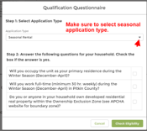

- Choose INDIVIDUAL.
- Enter work history and/or upcoming employer and start date. If not able to find employer under Business Account, please put employer name in Notes.
- Next is the APPLICATION section. You must select SEASONAL APPLICATION otherwise, you will be charged $50 instead of the seasonal $35 fee.
↙
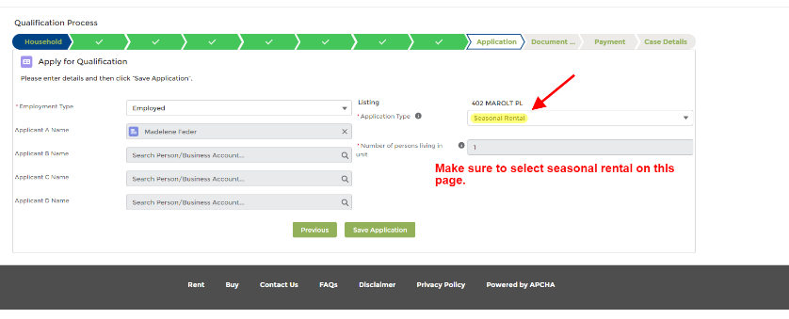

Help Desk: HomeTrekSupport@cityofaspen.com or 970-920-5259
Help Desk Hours: Monday-Friday 7:30AM – 4:30PM

